**TEAMDUTY Web-application**

Software Project management Plan

**By**

Mr. Manuchet Manoi 542115049

Mr. Saknarong Noipaksa 542115061

Department of Software Engineering

College of Arts, Media and Technology

Chiang Mai University

**Project Advisor**

______________________________________

**Aj. Jayakrit Hirisajja**

**Document History**

|  |  |  |  |  |  |  |  |
| --- | --- | --- | --- | --- | --- | --- | --- |
| **Document Name** | **Version** | **Status** | **Date** | **Viewable** | **Reviewer** | | **Responsible** |
| **Documents** | | | | | | | |
| TEAMDUTY - Web application - SPMP v 0.1.docx | **- Add Chapter 1**  -Identification  -Project Scope  -Document Overview  -Objective | Draft | 19 April 2014 | MM,  SN,JH | | MM,  SN | MM,  SN |
| TEAMDUTY - Web application - SPMP v 0.1.docx | **- Add Chapter 2**  -Key definition  -Key Acronym  **- Add Chapter 3**  **-**Project Team Structure  -Monitoring and Controlling Mechanisms  **- Add Chapter 5**  -Filename Format  -Document Repository  -Change Management | Draft | 20 April 2014 | MM,  SN,JH | | MM,  SN | MM,  SN |

**\*MM = Manuchet Manoi**

**\*SN = Saknarong Noipaksa**

**\*JH = Jayakrit Hirisajja**

**Table of Contents**

Chapter One | Introduction 4

1.1 Identification 4

1.2 Project Scope 4

1.3 Document Overview 4

1.4 Objective 4

Chapter Two | Definition and Acronyms 5

2.1 Key Definition 5

2.2 Key Acronyms 7

Chapter Three | Management Procedures 8

3.1 Project Team Structure 8

3.2 Monitoring and Controlling Mechanisms 8

Chapter Four | Estimated Duration of Tasks 10

Chapter Five | Software Configuration Management 11

5.1 Software Configuration Management 11

5.2 Filename Format 11

5.3 Document Repository 11

5.4 Change Management 12

5.5 Repository Tool 13

5.6 Software Configuration Item Table 14

Chapter Six | Quality Planning 15

4.1 Quality Factors 15

4.2 Review/Responsibility 16

4.3 Quality Standard 17

*4.3.1.1 Project Management (PM) process* 17

*4.3.1.2* *Software Implementation (SI) process* 18

Chapter Seven | Identification of Project 19

# Chapter One | Introduction

## Identification

This project is web application that provide software human resource and Auction software system .This web-application is centralize place between Software – employer and software-freelancer to contract, communicate and update progress about their software project together.

This document provide planning .scheduling, activities, and evaluating overall off project. This project management plan document is planning of “TEAM DUTY- Web-application”. This document provide detailed scheduled for team member, assigned task and identified risk of project.

## 1.2 Project Scope

The scope of this software project management plan is strategies to establish the system that:

* The Software System is Web-application.
* The Software System provide only software side.
* The Software System divide to two main part that is software human resource, and software job auction project.

## 1.3 Document Overview

Project management plan is a guideline to develop process of the system. This document consist of management procedure, estimated duration of tasks and identification of project risks

## 1.4 Objective

The objective of software document planning is analysis the detail of software project. The document provide planning detail which are responsibility of development team, scheduling activities and project risk .This project management plan can be used for the development team work more systematically .and reduce some risk that will occurs on software project

# Chapter Two | Definition and Acronyms

## 2.1 Key Definition

|  |  |
| --- | --- |
| **Baseline** | “A specification or product that has been formally reviewed and agreed upon, that thereafter serves as the basis for further development, and that can be changed only through formal change control procedures.” [IEEE90] |
| Configuration management | “A discipline applying technical and administrative direction and surveillance to: identify and document the functional and physical characteristics of a configuration item, control changes to those characteristics, record and report change processing implementation status, and verify compliance with specified requirements.” [IEEE90] |
| Feature | Transformation of input parameters to output parameters based on a specified algorithm. It describes the functionality of a product in the language of the product. Used for requirement analysis, design, coding, testing or maintenance. [IEEE90] |
| IEEE | Institute for Electrical and Electronics Engineer. Biggest global interest group for engineers of different branches and for computer scientists. [IEEE90] |
| Implementation | “Period of time in the software life cycle during which a software product is created from documentation and debugged” [IEEE90] |
| Milestone | A significant event in the project, usually completion of a major deliverable [IEEE90] |
| **Plan** | A documented series of tasks required meeting an objective, typically including the  Associated schedule, budget, resources, organizational description and work breakdown Structure. |
| **Project Management** | The application of knowledge, skills, tools, and techniques to  Project activities in order to meet or exceed stakeholder needs and expectations from a project. |
| **Project Plan** | A formal, approved document used to guide both project execution and project  Control. The primary uses of the project plan are to document planning assumptions and decisions, to facilitate communication among stakeholders, and to document approved scope, cost, and schedule baselines. |
| **Requirement** | (1) Need or expectation that is stated, customarily implied or obligatory  (2) A Condition or capability needed by user to solve a problem or achieve an objective.[IEEE90] |
| **Risk** | A function of the probability of occurrence of a given threat and the potential adverse consequences of that threat's occurrence. |
| **Risk Management** | The systematic application of management policies, procedures and  practices to the tasks of identifying, analyzing, evaluating, treating and monitoring risk.[IEEE90] |
| **Specification** | A document that specifies, in a complete, precise, verifiable manner, the requirements, design, behavior, or other characteristics of a system or component, and, often, the procedures for determining whether these provisions have been satisfied. |
| **Software** | “Computer programs, procedure ,and associated documentation and data pertaining to the operation of a computer system ” [IEEE90] |
| **System** | An integrated composite that consists of one or more of the processes, hardware, software, facilities and people, that provides a capability to satisfy a stated need or objective. |
| **Traceability** | Expresses relationships between software artefacts that reside in *different* phases of the [software life-cycle](http://informatique.umons.ac.be/genlog/SE/SE-contents.html#SoftwareLifeCycle), e.g. dependencies between a requirements specification and a design component |
| **Unit test** | A test of individual programs or modules in order to ensure that there are no analysis or programming errors.[IEEE90] |
| **User** | An individual or organization that uses the operational system to perform a specific function. [IEEE90] |
| **Website** | [Document](http://en.wikipedia.org/wiki/Document), typically written in [plain text](http://en.wikipedia.org/wiki/Plain_text) interspersed with formatting instructions of Hypertext Markup Language ([HTML](http://en.wikipedia.org/wiki/HTML),[XHTML](http://en.wikipedia.org/wiki/XHTML)). A webpage may incorporate elements from other websites with suitable [markup anchors](http://en.wikipedia.org/wiki/HTML_anchor). |

## 2.2 Key Acronyms

ASP – Active Server Page

CSS - Cascading Style Sheets

[HTML](http://en.wikipedia.org/wiki/HTML) – Hyper Text Markup Language

IEEE – Institute of Electrical and Electronics Engineers

MVC - Model View Controller

SPMP – Software Project Management Plan

SDD – Software Design Document

SRS – Software Requirement Specification

SCI – Software Configuration Item

# Chapter Three | Management Procedures

## 3.1 Project Team Structure

|  |  |
| --- | --- |
| **Participants** | **Activity** |
| Manuchet Manoi  And  Saknarong Noipaksa | Feasibility Study |
| Project Proposal |
| Project Requirement |
| Project Plan & Project Design |
| Implementation |
| Testing |
| Change Document |

## 3.2 Monitoring and Controlling Mechanisms

**3.2.1 Project Meeting**

|  |  |
| --- | --- |
| **Participants** | **Activity** |
| Mr.Manuchet Manoi | Development Team |
| Mr.Saknarong Noipaksa | Development Team |
| Mr.Jayakrit Hirisajja | Advisor |

**3.2.2 Software Development Model**

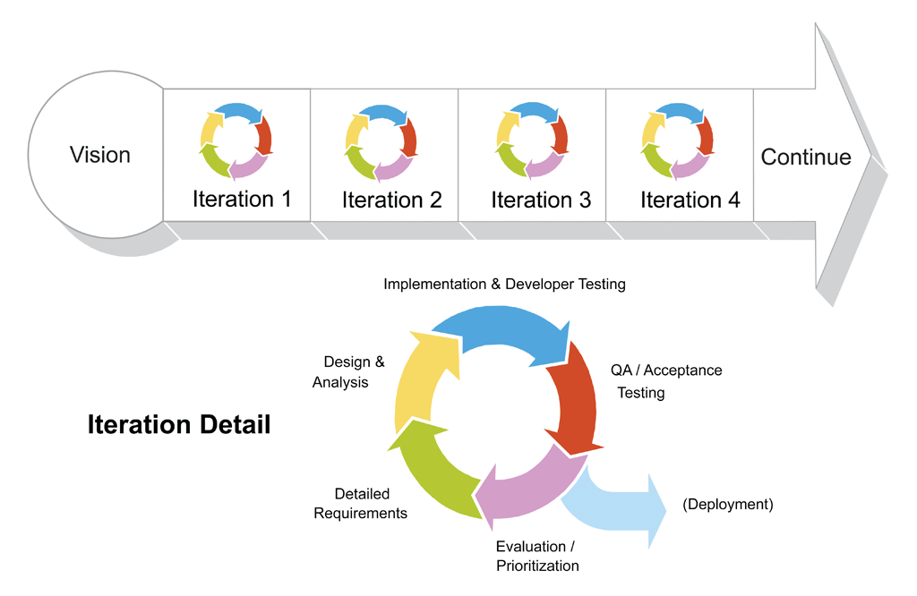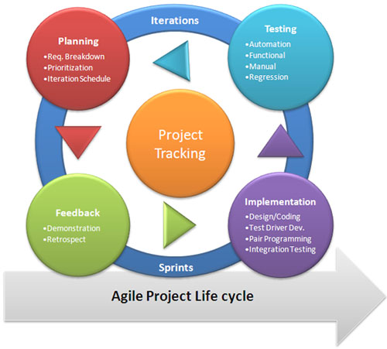**Agile Model**

***Figure 3.2.2: Agile Model and Iterative Model expanding***

**Agile software development** is a group of [software development methods](http://en.wikipedia.org/wiki/Software_development_methodologies) based on [iterative and incremental development](http://en.wikipedia.org/wiki/Iterative_and_incremental_development), where requirements and solutions evolve through collaboration between self-organizing, [cross-functional teams](http://en.wikipedia.org/wiki/Cross-functional_team). It promotes adaptive planning, evolutionary development and delivery, a [time-boxed](http://en.wikipedia.org/wiki/Timeboxing) iterative approach, and encourages rapid and flexible response to change. It is a conceptual framework that promotes foreseen tight iterations throughout the development cycle.

***http://en.wikipedia.org/wiki/Agile_software_development***

# Chapter Four | Estimated Duration of Tasks

|  |  |  |  |
| --- | --- | --- | --- |
| **No** | **Event** | **Tasks** | **Duration** |
| **1** | **Project Proposal** | **Document**  -Project Proposal | **42 days** |
| **2** | **Project Progress Report 1** | **Document**  -Software Project Management Plan  -Software Requirement Specification  -Test Plan for Progress 1  -Test Record for Progress 1  -Software Design Document 1  **Media**  -Presentation slide  **Software Prototype**  Feature 1,2 | **57 days** |
| **3** | **Project Progress Report 2** | **Document**  -Software Project Management Plan  -Software Requirement Specification  -Test Plan for Progress 2  -Test Record for Progress 2  -Software Design Document 2  **Media**  -Presentation slide  **Software Prototype**  Feature 3,4 | **69 days** |
| **4** | **SE Show Pro** | **Document**  -Poster A1  **Media**  -Introduction clips | **1 days** |
| **5** | **Project Final** | **Document**  -Software Project Management Plan  -Software Requirement Specification  -Test Plan for Progress 3  -Test Record for Progress 3  -Software Design Document 3  **Media**  -Presentation slide  **Software Prototype**  Feature 5-7 | **49 days** |

# Chapter Five | Software Configuration Management

## 5.1 Software Configuration Management

Software Configuration Management is the task of tracking and controlling changes in the software by identifying the work products that are likely to change in software project, if something goes wrong, SCM can determine what was changed and who changed it with our system.

## 5.2 Filename Format

*Version separates into two categories which are Draft and Issues:*

- Draft is version 0.x (i.e. 0.1, 0.2, and 0.3)

- Issued is version x.0 (i.e. 1.0, 2.0, and 3.0)

*The filename format that we using for all project document is;*

- [Project name] – [Document name] v [Version]. [File type]

(I.E. TEAMDUTY - Web application - SPMP v 0.1.docx)

## 5.3 Document Repository

This project collected all file in folder name “Senior Project root Teamduty” separated sub folder by document name to collect all document versions. There are Proposal, Project Management, Software Requirement Specification, Software Design Document, Test Plan, Test Record, Project Status, and Traceability

## 5.4 Change Management

Change Management is process to manage project. When project is not follow the planning or some problem is occur while developing project.Developement team has method to manage problems by analyzing to find best solution then create new plan for project by development team. Changing will record in Change Management and every change must be agree by advisor first

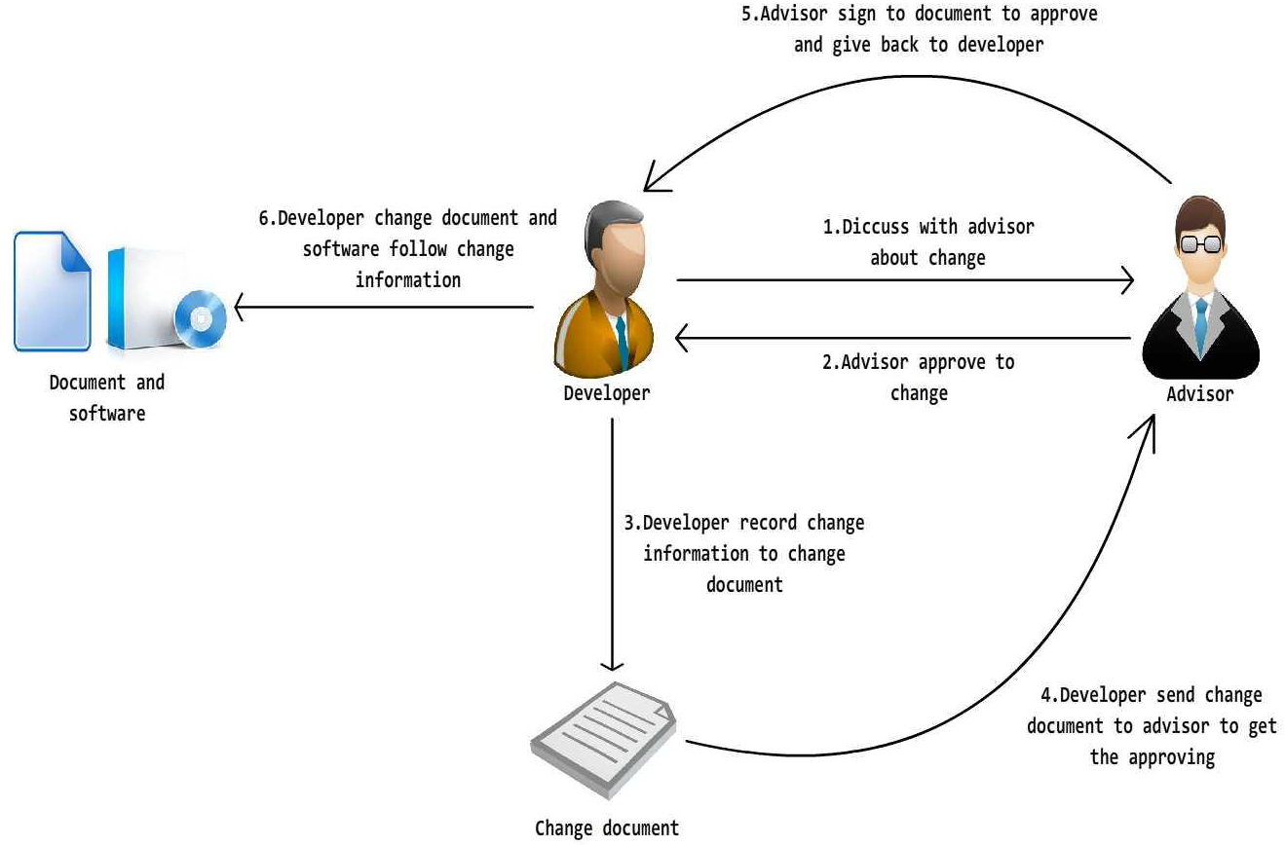

*Figure 5.4 Flow of change management*

## 5.5 Repository Tool

**GitHub** is a [web-based hosting service](http://en.wikipedia.org/wiki/Shared_web_hosting_service) for software development projects that use the [Git](http://en.wikipedia.org/wiki/Git_(software)) [revision control](http://en.wikipedia.org/wiki/Revision_control) system. GitHub offers both paid plans for private repositories, and free accounts for [open source](http://en.wikipedia.org/wiki/Open_source) projects.Product need to Register and install in Computer before use. Our developer can use Github to control V of Program and Document in project and Developer can created folder and shared project to project mate.

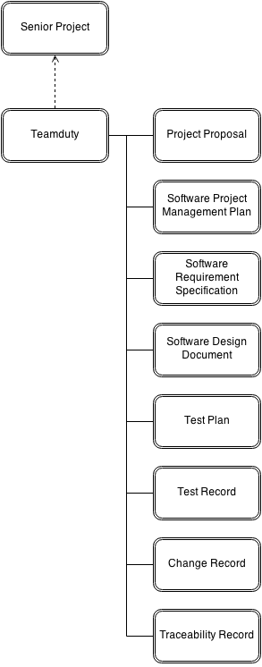For TEAMDUTY – Web Application project, we will create folders to be the project repository as following;

*Figure 5.5 Flow of root folder repository in Github*

## 5.6 Software Configuration Item Table

|  |  |  |  |  |  |  |
| --- | --- | --- | --- | --- | --- | --- |
| **No.** | **Item** | **File Name** | **File Type** | **Owner** | **Path** | **Baseline** |
| 1 | Project Proposal | On Sale notification -Proposal-V.[version].docx | .docx | MN,SN | C:\Users\SAMSUNG\Desktop\Senior project\Teamduty\Proposal | 1.1 |
| 2 | Software Project Management Plan | TEAMDUTY - Web application - SPMP v [Version].docx | .docx | MN,SN | C:\Users\SAMSUNG\Desktop\Senior project\Teamduty\SPMP | - |
| 3 | Software Requirement Specification | TEAMDUTY – Web application - SRS v [Version].docx | .docx | MN,SN | C:\Users\SAMSUNG\Desktop\Senior project\Teamduty\SRS | - |
| 4 | Software Design Document | TEAMDUTY – Web application - SDD v [Version].docx | .docx | MN,SN | C:\Users\SAMSUNG\Desktop\Senior project\Teamduty\SDD | - |
| 5 | Test Plan | TEAMDUTY – Web application – Test Plan v [Version].docx | .docx | MN,SN | C:\Users\SAMSUNG\Desktop\Senior project\Teamduty\Test Plan | - |
| 6 | Test Record | TEAMDUTY – Web application – Test Record v [Version].docx | .docx | MN,SN | C:\Users\SAMSUNG\Desktop\Senior project\Teamduty\Test Record | - |
| 7 | Change Record | TEAMDUTY – Web application – Change Record v [Version].docx | .docx | MN,SN | C:\Users\SAMSUNG\Desktop\Senior project\Teamduty\CR | - |
| 8 | Traceability | TEAMDUTY – Web application - Traceability v [Version].docx | .docx | MN,SN | C:\Users\SAMSUNG\Desktop\Senior project\Teamduty\TR | - |

# Chapter Six | Quality Planning

## 4.1 Quality Factors

**Product operation factors**

* **Correctness** - The software product should able to provide more than 90% correctness of data from user traditional request.
* **Reliability** - The software should able to handle more than 90% of traditional activity with less than 10% of software’s failure.

**Product revision factors**

* **Maintainability** - The software should have 20-30% of comment comparing with the whole LOC to support the future maintenance activity.
* **Testability** - The software should able to be tested 100% of it defined routine and functionality.

**Product transition factors**

* **Reusability** - More than 20% part of finished software product should able to be reused in future development.

## **4.2** Review/Responsibility

|  |  |  |  |
| --- | --- | --- | --- |
| **Stage Exit Review** | | | |
| **No.** | **Stage** | **Review Item** | **Responsibility** |
| 1. | Progress#1 | - Project Plan  - Quality Plan | AK, TP, KS |
| 2. | Progress#1 | - Software Requirement Specification 1 | AK, TP, KS |
| 3. | Progress#1 | - Software Design Document 1 | AK, TP, KS |
| 4. | Progress#1 | - Test Plan 1 | AK, TP, KS |
| 5. | Progress#1 | - Test Record 1 | AK, TP, KS |
| 6. | Progress#1 | - Traceability Record 1 | AK, TP, KS |
| 7. | Progress#2 | - Software Requirement Specification 2 | AK, TP, KS |
| 8. | Progress#2 | - Software Design Document 2 | AK, TP, KS |
| 9. | Progress#2 | - Test Plan 2 | AK, TP, KS |
| 10. | Progress#2 | - Test Record 2 | AK, TP, KS |
| 11. | Progress#2 | - Traceability Record 2 | AK, TP, KS |
| 12. | Progress#3 | - Software Requirement Specification 3 | AK, TP, KS |
| 13. | Progress#3 | - Software Design Document 3 | AK, TP, KS |
| 14. | Progress#3 | - Test Plan 3 | AK, TP, KS |
| 15. | Progress#3 | - Test Record 3 | AK, TP, KS |
| 16. | Progress#3 | - Traceability Record 3 | AK, TP, KS |
| 17. | Final Progress | - Software Requirement Specification ( Complete ) | AK, TP, KS |
| 18. | Final Progress | - Software Design Document ( Complete ) | AK, TP, KS |
| 19. | Final Progress | - Test Plan ( Complete ) | AK, TP, KS |
| 20. | Final Progress | - Test Record ( Complete ) | AK, TP, KS |
| 21. | Final Progress | - Traceability Record  ( Complete ) | AK, TP, KS |

## 4.3 Quality Standard

**4.3.1 ISO29110 for Very Small Entity (VSE)**

The ISO29110 contain 2 processes are Project management and Software implementation.

* Project Management (PM) process
* Software Implementation (SI) process

### ***4.3.1.1 Project Management (PM) process***

**Purpose**

To establish and carry out in a systematic way the tasks of the software implementation project, which allows complying with the project’s objectives in the expected quality, time and costs.

**Objective**

* PM.O1. The Project Plan for the execution of the project is developed according to the Statement of Work and validated with the Customer. The tasks and resources necessary to complete the work are sized and estimated.
* PM.O2. Progress of the project is monitored against the Project Plan and recorded in the Progress Status Record.
* PM.O3. The Change Requests are addressed through their reception and analysis. Changes to software requirements are evaluated for cost, schedule and technical impact.
* PM.O4. Review meetings with the Work Team and the Customer are held. Agreements are registered and tracked.
* PM.O5. Risks are identified as they develop and during the conduct of the project.
* PM.O6. A software Version Control Strategy is developed. Items of Software Configuration are identified, defined and baseliner. Modifications and releases of the items are controlled and made available to the Customer and Work Team including the storage, handling and delivery of the items
* PM.O7. Software Quality Assurance is performed to provide assurance that work products and processes comply with the Project Plan and Requirements Specification.

### ***4.3.1.2*** ***Software Implementation (SI) process***

**Purpose**

The purpose of the Software Implementation process is the systematic performance of the analysis, design, construction, integration and tests activities for new or modified software products according to the specific requirements

**Objective**

* SI.O1. Tasks of the activities are performed through the accomplishment of the current Project Plan.
* SI.O2. Software requirements are defined, analyzed for correctness and testability, approved by the Customer, baselined and communicated.
* SI.O3. Software architectural and detailed design is developed and baselined. It describes the software items and internal and external interfaces of them. Consistency and traceability to software requirements are established.
* SI.O4. Software components defined by the design are produced. Unit test are defined and performed to verify the consistency with requirements and the design. Traceability to the requirements and design are established.
* SI.O5. Software is produced performing integration of software components and verified using Test Cases and Test Procedures. Results are recorded at the Test Report. Defects are corrected and consistency and traceability to Software Design are established.
* SI.O6. A Software Configuration, that meets the Requirements Specification as agreed to with the Customer, which includes user, operation and maintenance documentations is integrated, baselined and stored at the Project Repository. Needs for changes to the Software Configuration are detected and related Change Requests are initiated.
* SI.O7. Verification and Validation tasks of all required work products are performed using the defined criteria to achieve consistency among output and input products in each activity. Defects are identified, and corrected; records are stored in the Verification/Validation Results.

# Chapter Seven | Identification of Project

|  |  |  |  |
| --- | --- | --- | --- |
| **Risk ID** | **Risk** | **Solution** | **Priority** |
| **1** | Cannot finish project follow the schedule | - Start project before schedule and take more effort to do project such as spend more hours to do project , do project on holiday , etc. | High |
| **2** | Requirement Change | - Discuss with advisor.  - Use traceability record to control change. | High |
| **3** | Developers lack necessary skill for development the project. | - Need studying and training time for developers.  - Discuss with people who have knowledge about topic which is required for development. | High |